Requirement Analysis
Data Flow Diagram & User Stories

Date | 29-06-2026
Project Name | Automated Network Request Management
Team ID
Maximum Marks

Part 1: Data Flow Diagram (DFD)
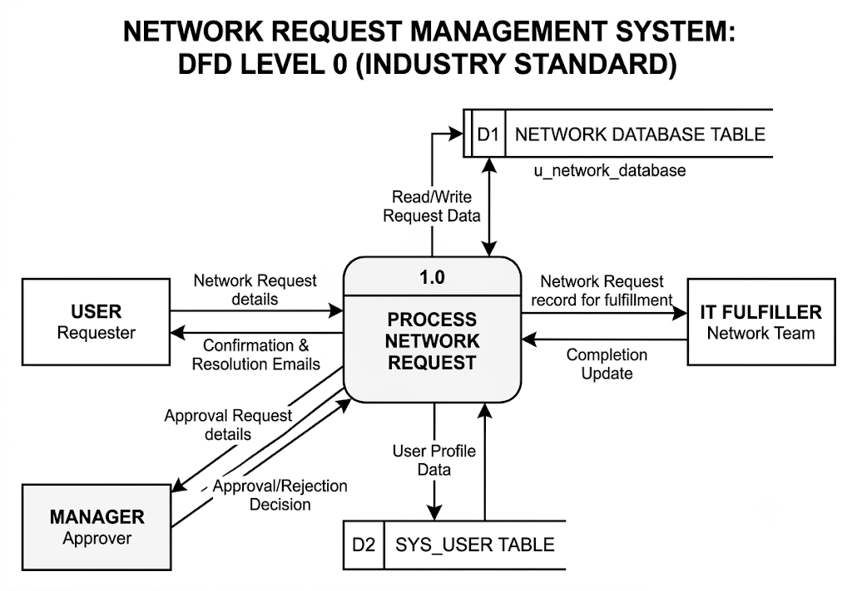

Simplified Flow Steps:

Phase 1: Request Ingestion & Data Validation
- Data Origin: The End-User populates a customized form on the ServiceNow Service Portal.
- Data in Transit: The user inputs specific network variables (e.g., Source IP, Destination IP, Target Port, and Business Justification).
- Process: ServiceNow client-side and server-side UI Policies sanitize and format the data (e.g., verifying regex patterns for valid IP addresses) before creating a requested item (sc_req_item) record.

Phase 2: Governance & Flow Logic
- Process: The Flow Designer Engine evaluates the incoming data payload against pre-defined business rules.
- Data Movement: * The engine checks configuration item (CI) relationships inside the CMDB to evaluate risk.
  - If the request is marked high-risk, a data notification is sent to the Manager/Security team, who returns an "Approved" or "Rejected" token.
  - If pre-approved (low-risk), the workflow bypasses manual intervention and packages the clean operational parameters for the integration layer.

Phase 3: Integration & Infrastructure Provisioning
- Process: Integration Hub transforms the structured ServiceNow record variables into a JSON or XML payload tailored for the destination infrastructure.
- Data Outbound: ServiceNow initiates an outbound HTTPS REST API call (or triggers an Ansible playbook via an orchestration spoke) passing the specific payload parameters to the network controllers (e.g., Palo Alto Panorama, Cisco DNA Center, or Infoblox IPAM).
- Action: The network controllers process the API command and apply the rule change directly to the physical or cloud hardware.

Phase 4: Closed-Loop Verification & Audit Logging
- Data Inbound: The network infrastructure API sends back a synchronous response payload containing the execution status (e.g., 200 OK or Error Code) along with deployment logs.
- Process: * ServiceNow parses the response data.
  - If successful, a data write command is sent to the CMDB to update configuration records, and an immutable log entry is generated for future compliance audits.
  - An automated email/notification updates the End-User that their request is live.

Part 2: User Stories
Here is a set of comprehensive, production-ready Agile User Stories tailored for the Automated Network Request Management (ANRM) ServiceNow project, structured in the requested tabular format.

ServiceNow ANRM User Stories & Tasks
User Type | Functional Requirement | User Story / Task | Acceptance Criteria | Priority
End-User (Developer / Requestor) | Self-Service Request Intake | As an End-User,I want a dedicated Service Catalog form for firewall port requests,So that I can request access without tracking down a network engineer. | • Form must include mandatory fields: Source IP, Destination IP, Ports, Protocol (TCP/UDP), and Business Justification. • Form must dynamically show/hide advanced routing choices based on user role. | High
IT Ops Manager (Approver) | Automated Governance / Approval Routing | As an IT Operations Manager,I want low-risk requests auto-approved and high-risk requests routed to my queue,So that standard requests aren't delayed by manual approvals. | • Flow Designer must evaluate request criteria against a predefined risk matrix. • Requests with known standard ports (e.g., 443) auto-approve instantly. • High-risk ports (e.g., 22, 3389) trigger an email/system approval notification to the manager. | High
ServiceNow Dev (Fulfiller) | Integration Hub API Integration | As a ServiceNow Developer,I want Integration Hub to trigger REST API payloads to the network controller,So that configuration changes are applied programmatically. | • Upon approval token, Integration Hub must compile form data into a valid JSON payload. • Payload must be securely sent to the target API endpoint (e.g., Palo Alto/Ansible) using encrypted credentials. • System must capture synchronous HTTP response codes (200 OK for success). | Critical
Network Administrator (Auditor) | Automated Verification & CMDB Logging | As a Network Admin,I want the system to test the connection and log details to the CMDB,So that our inventory remains accurate and compliant. | • Post-execution step must verify connectivity status. • On success, the script must write a configuration relationship record back to the target CI in the CMDB. • The RITM (Requested Item) ticket must lock down an uneditable audit log containing who requested, who approved, and API logs. | Medium
End-User (Developer / Requestor) | Real-Time Notification & Visibility | As an End-User,I want real-time status updates on my request,So that I don't have to send follow-up emails to see if it's done. | • System must trigger automated notifications (Email or Slack/Teams webhook) at three milestones: Submitted, Approved/In-Flight, and Fulfilled/Closed. • If an API push fails, notification must alert NetOps with the failure logs. | Low

